|  |  |
| --- | --- |
| S.NO | CONTENTS |
| 01 | **INTRODUCTION** |
| 02 | **REQUIREMENTS** |
| 03 | **REQUIREMENTS SPECIFICATION** |
| 04 | **ANALYSIS AND DESIGN** |
| 05 | **IMPLEMENTATION** |
| 06 | **TESTING** |
| 07 | **CONCLUSION** |

**1 INTRODUCTION**

* The application deals with computerizing the most manual works of an online car showroom which enables it, to better adopt to change in growing world’s demand. The car showroom and service details collected can direct the administrator to efficiently utilize & monitor the whole car showroom & service

This is intended to employ the simple functionality that car showroom would like to add to their static & dynamic information which allows car showroom to choose according to their needs online.

* 1. **Proposed system:**

The System becomes user friendly, very reliable, smooth, Fast. All of features are listed below. Using application online makes the job easier since most of the work is done by the application. All customer’s and vehicle information will be in less than one platform. Since the data is saved under one roof, retrieving the data when required becomes easier. Any authorized person will be able to retrieve this data without waiting for other. With online the data can be accessed anywhere in the word which are connected to the desired servers.

Employee becomes confused and frustrated while handling multiple files at a same time. Using this automated software all the information handling of multiple documents at a time becomes easier since all the data is saved at a particular place and a pre described format which is 100% accurate.

After computerization the system can replace all the documents in data processing software. There are many customer’s file in which all the information about the customer and vehicle are stored. These data are stored into the database server. Which require fewer places and reducing the documentation?

The major advantage of the computerization is to reduce the time required to finding the records. Complete history of the customer account can be viewed just by entering the username.

**1.2 Existing system:**

* The current system is time consuming and requires manpower since it is done manually.
* Room respective car showroom manually.

**2.** REQUIREMENT ANALYSIS

**2.**1 Hardware Requirements:

* Active LAN which is connected to the internet
* SQL Data Server
* N no of Client devices

Software used in designing (code) of the system:

* Operating System : Microsoft Windows® 10 x64.
* Application Software’s : HTML, CSS3 JAVASCRIPT [front-end tool]

MySQL Database [back-end tool]

Web browser

SERVER SIDE PHP

**3**. ANALYSIS AND DESIGN

**3.1 Entity Relationship (ER) Diagrams.**

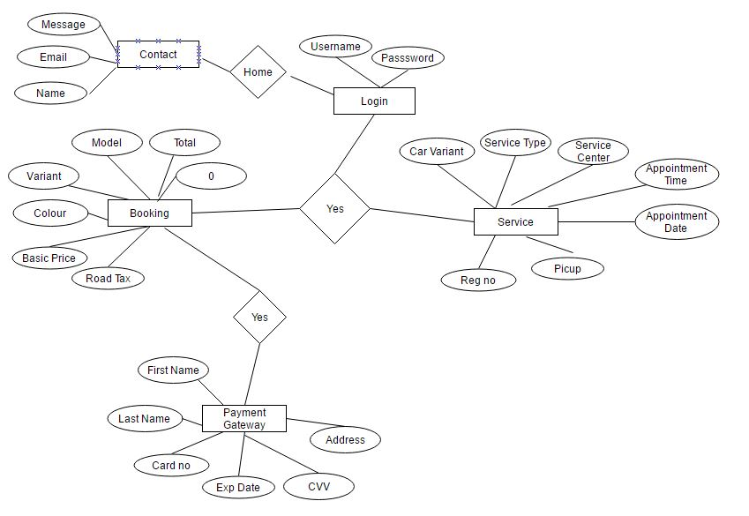

**3.2 DFD (Data Flow Diagram)**

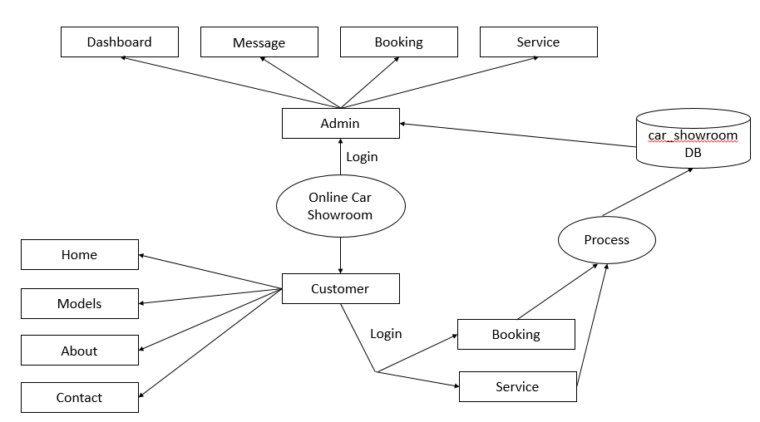

**3.3** Tables

**Booking table**

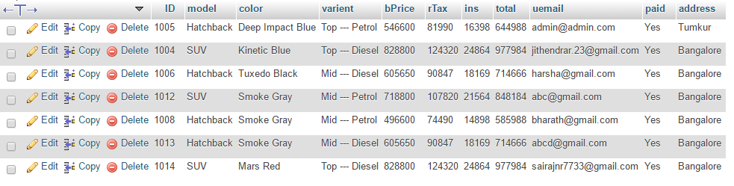

Service table

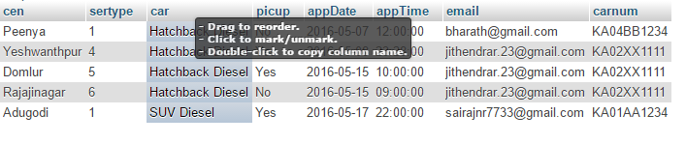

Price table

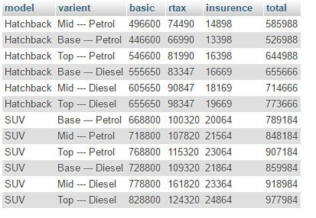

Login and signup

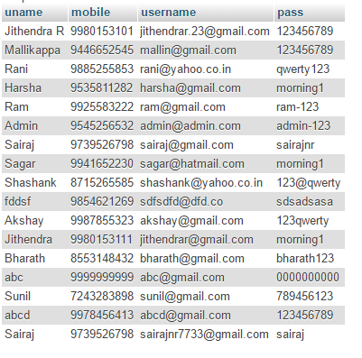

Contact Table

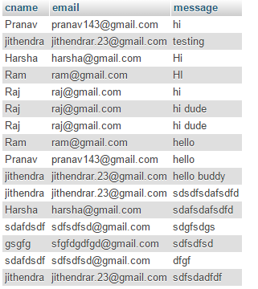

**4.** IMPLEMENTATION

The final and important phase in the system life cycle is the implementation of the new system. The term implementation has different meaning, ranging from the conventions of the basic applications to a complete replacement of the computer system. The procedure however is virtually the same. Implementation includes all those activities that take place to convert from old system to new. The coding of the proposed system is done with enough documentation. The method of implementation and the time scale to be adopted is found out initially. Next the system is tested properly and at the same time the user is trained with the new procedure. Proper implementation is essential to provide a reliable system to meet organization’s requirement. Successful implementation may not guarantee improvement in the organization using the system, but it will prevent improper installation.

**4.1** Steps to run the project

1. Install Dream viewer 8, Wamp sever (it consists of MYSQL database along with server)

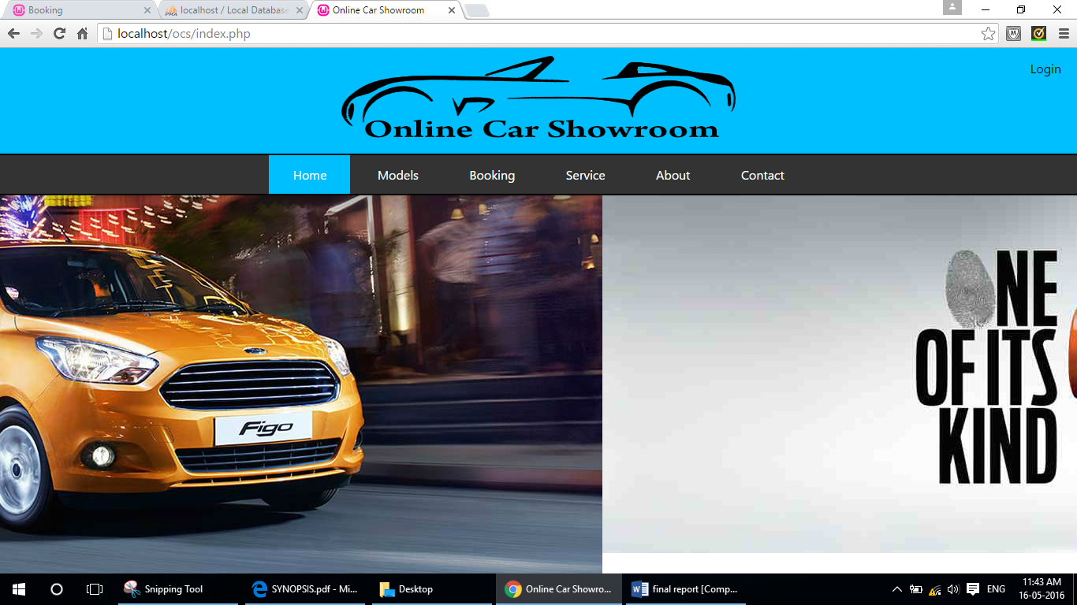

**Wamp**

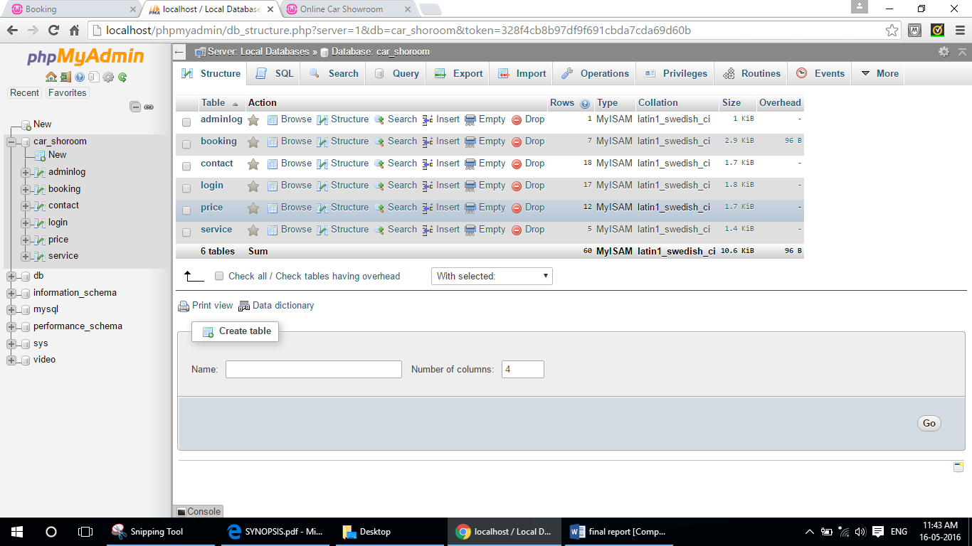

1. After installation of wamp server, create the tables with proper attributes.
2. Create the web pages required according to the database modules using dream viewer and link them together with PHP code.
3. Run the web pages in browser using local host path name followed by the file and folder name of the file to run.

**4.2** SCREEN SHOTS

Below image is the main home page of the application where the specified users can login accordingly

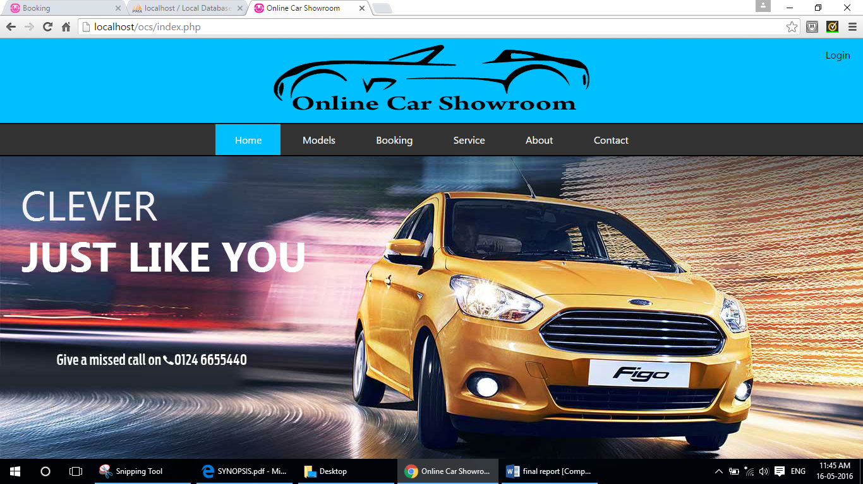

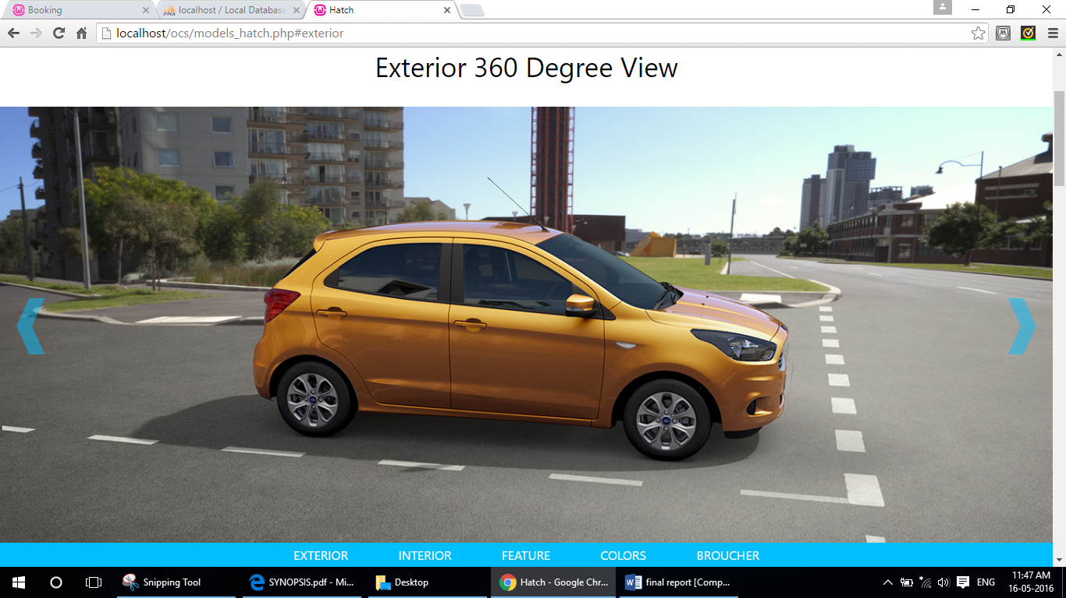

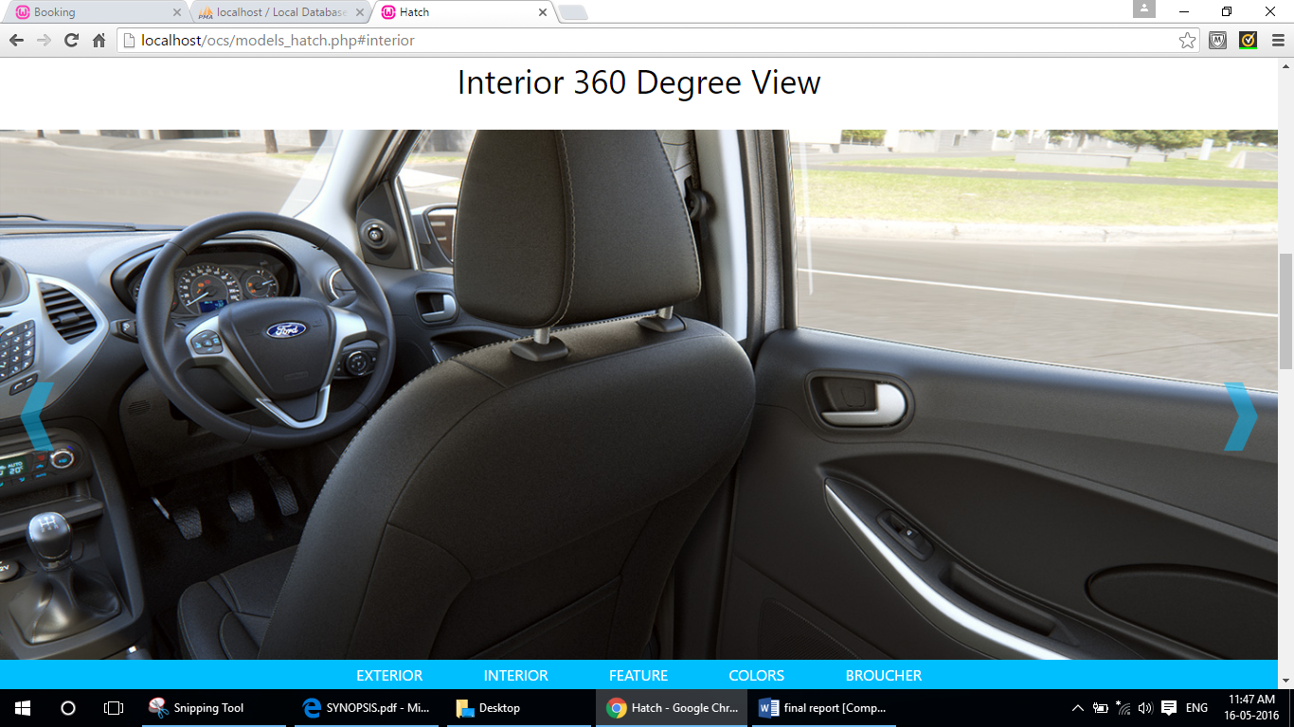

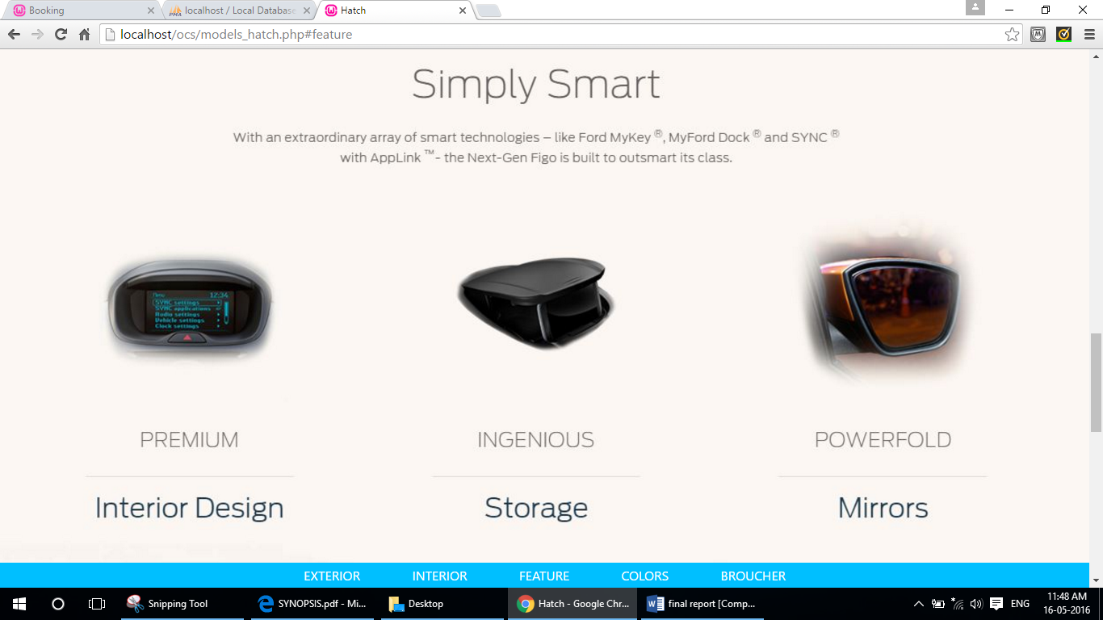

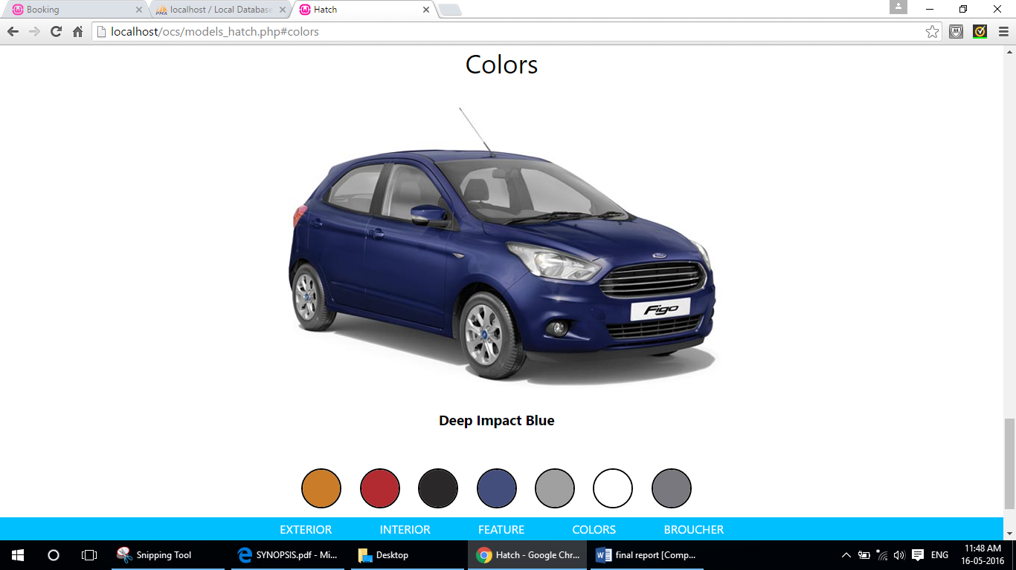

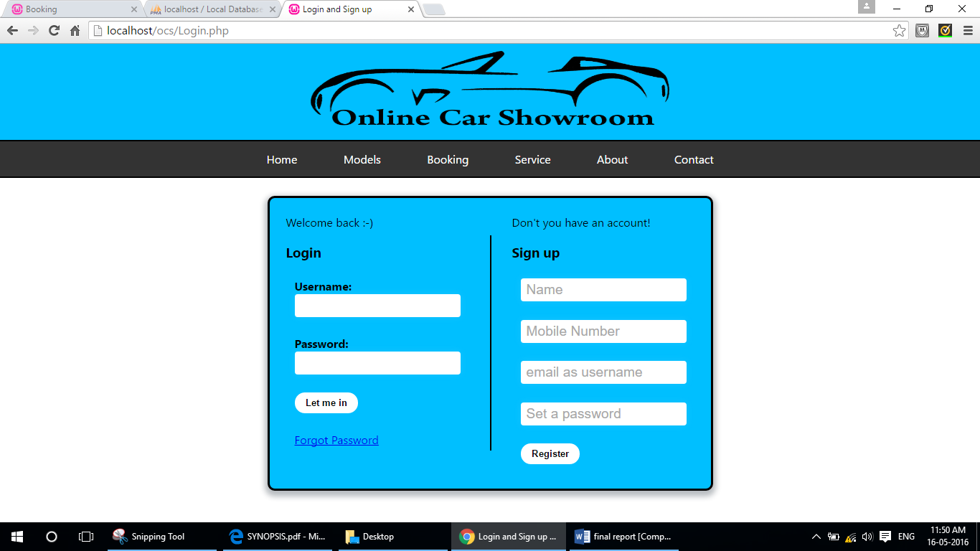

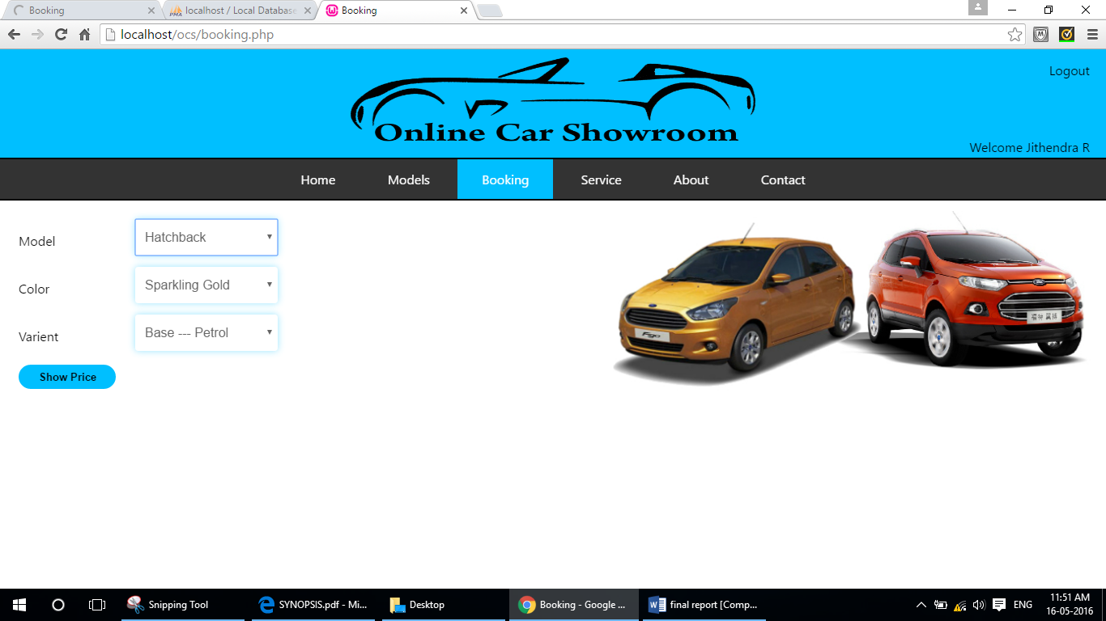

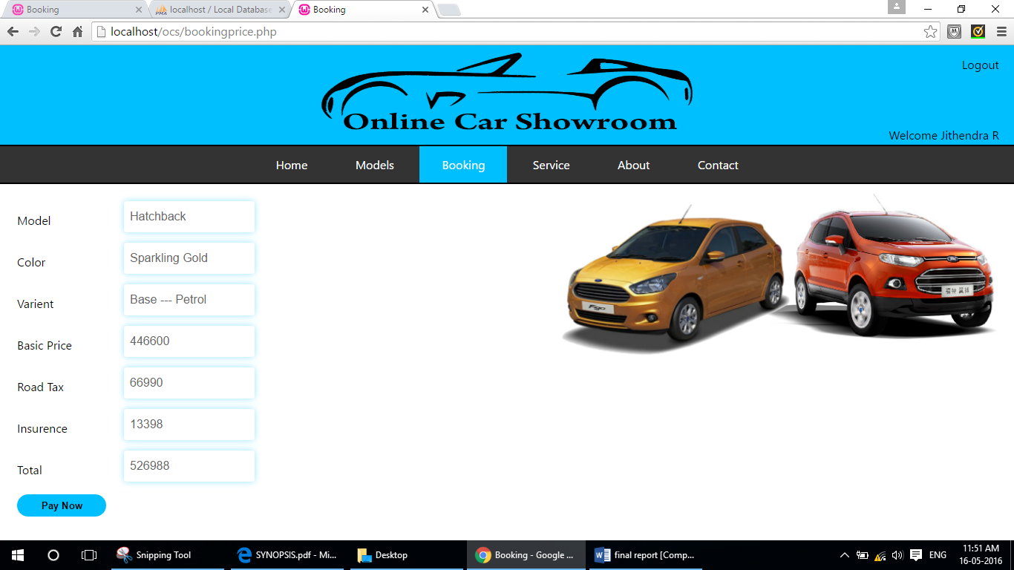

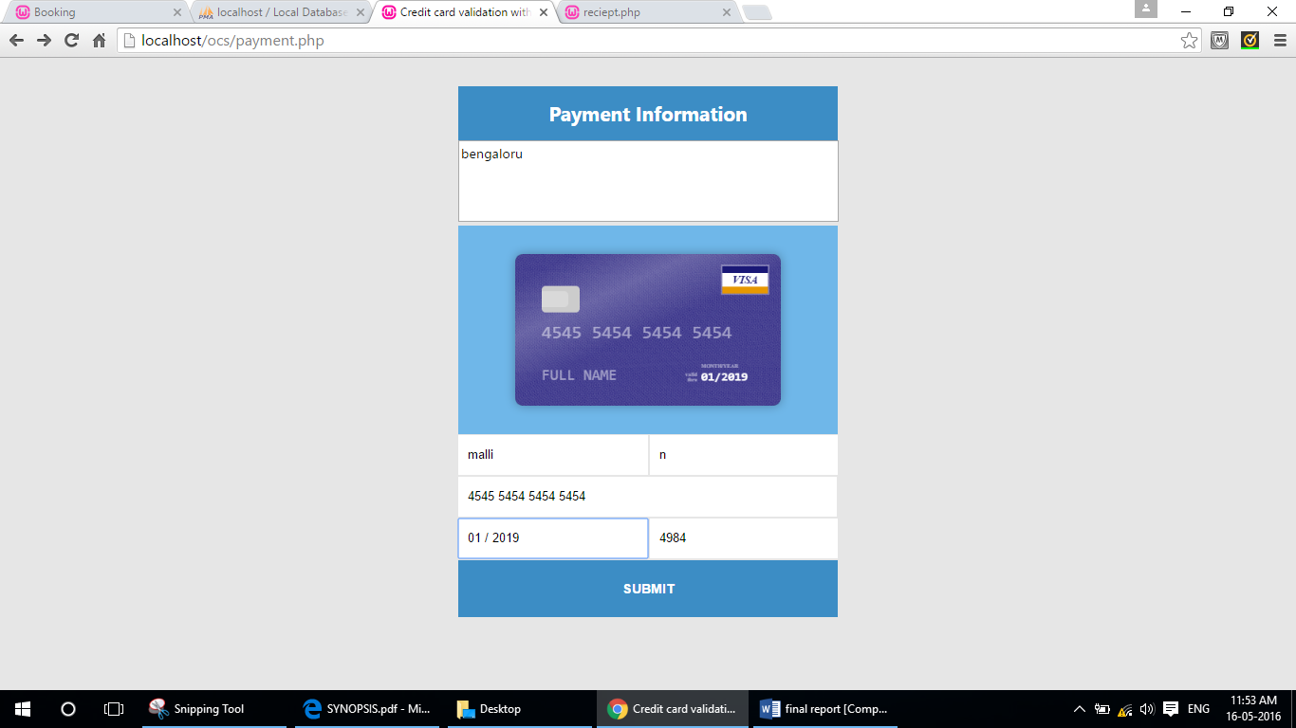

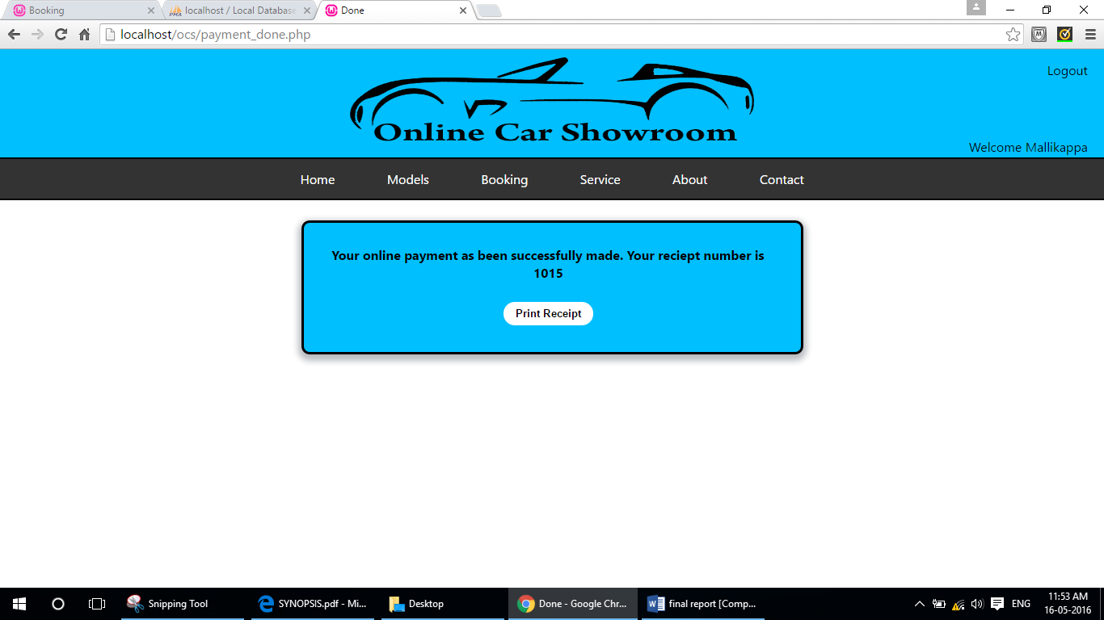

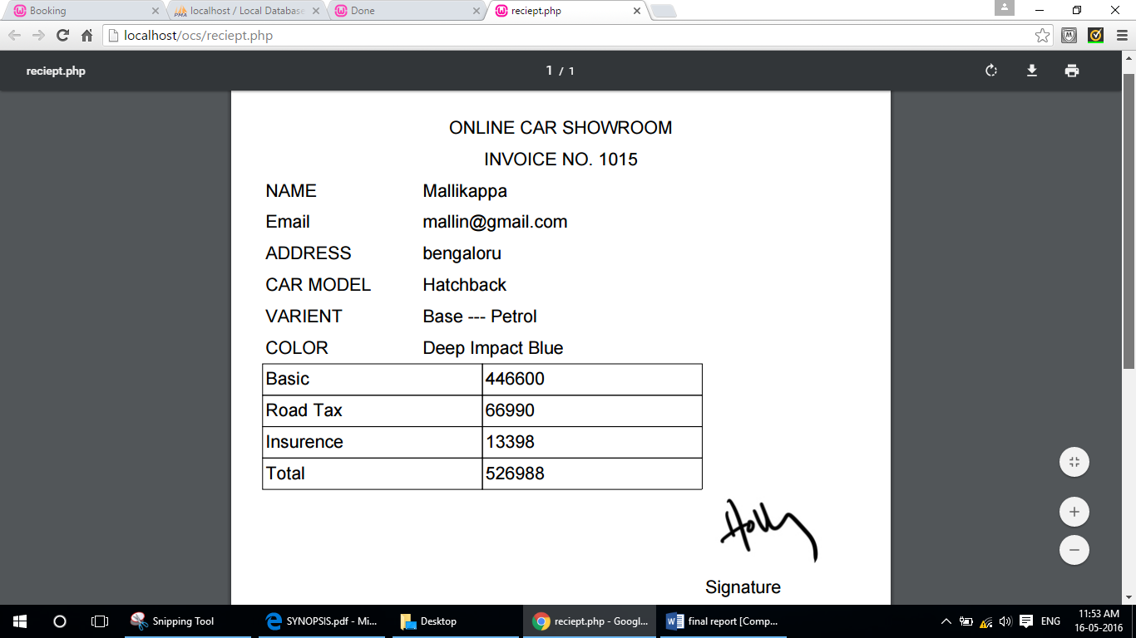

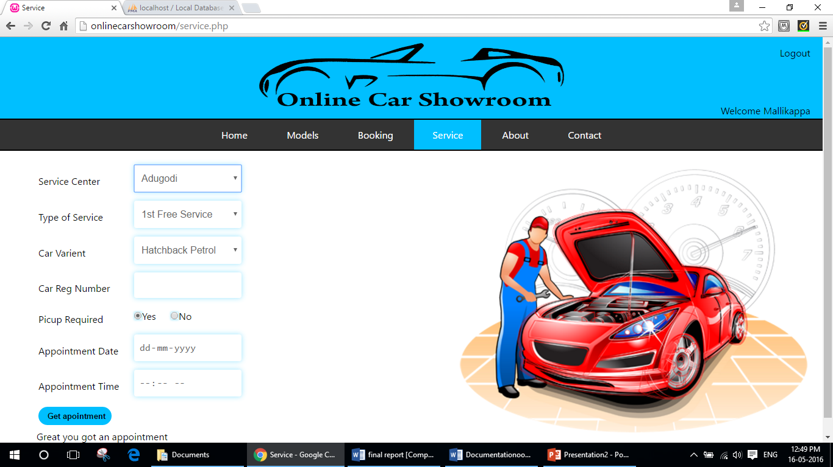

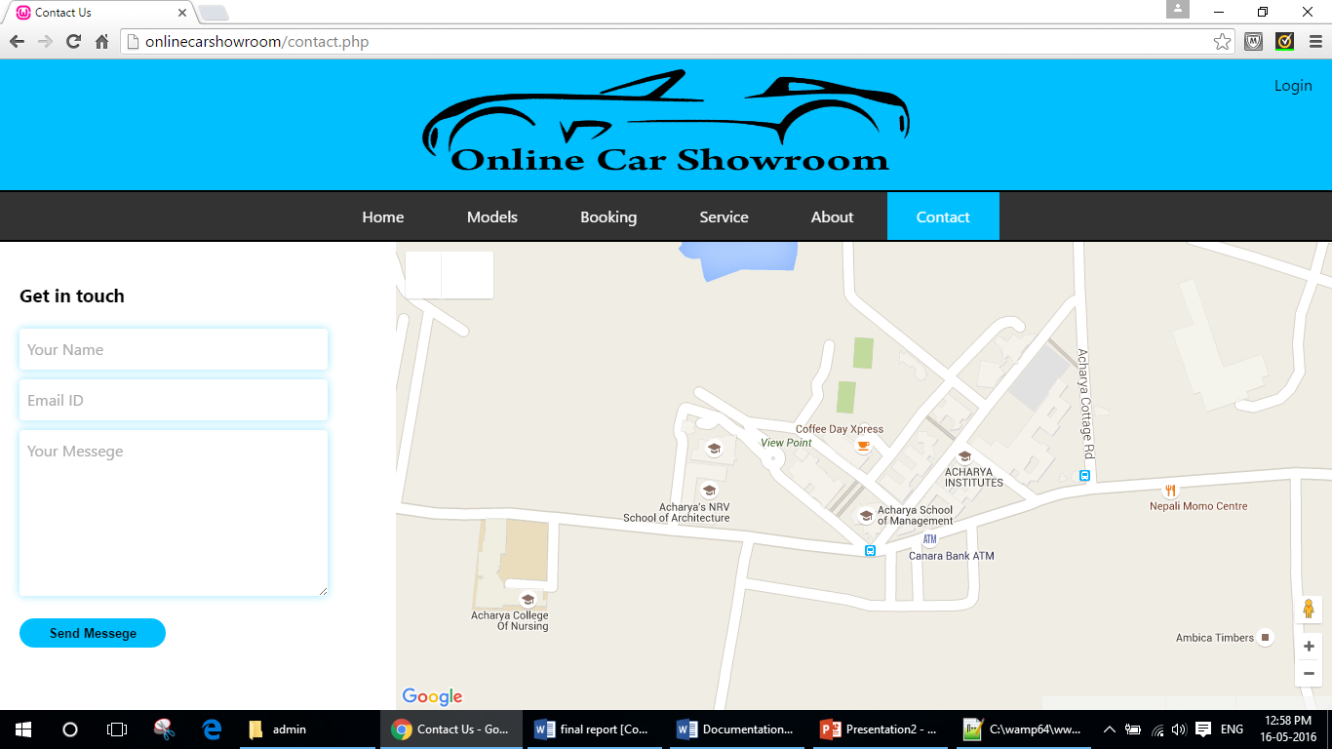

ADMIN

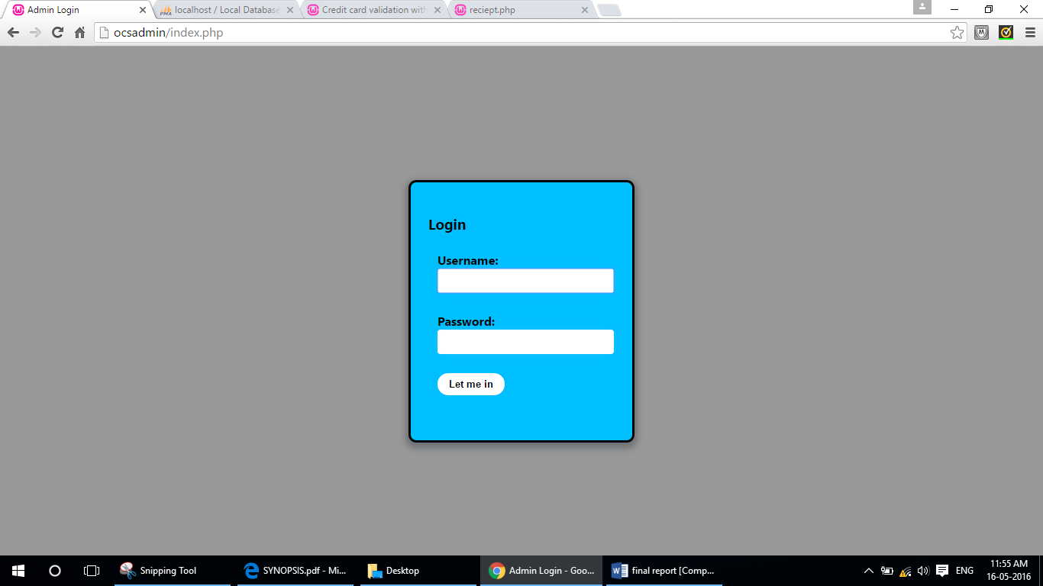

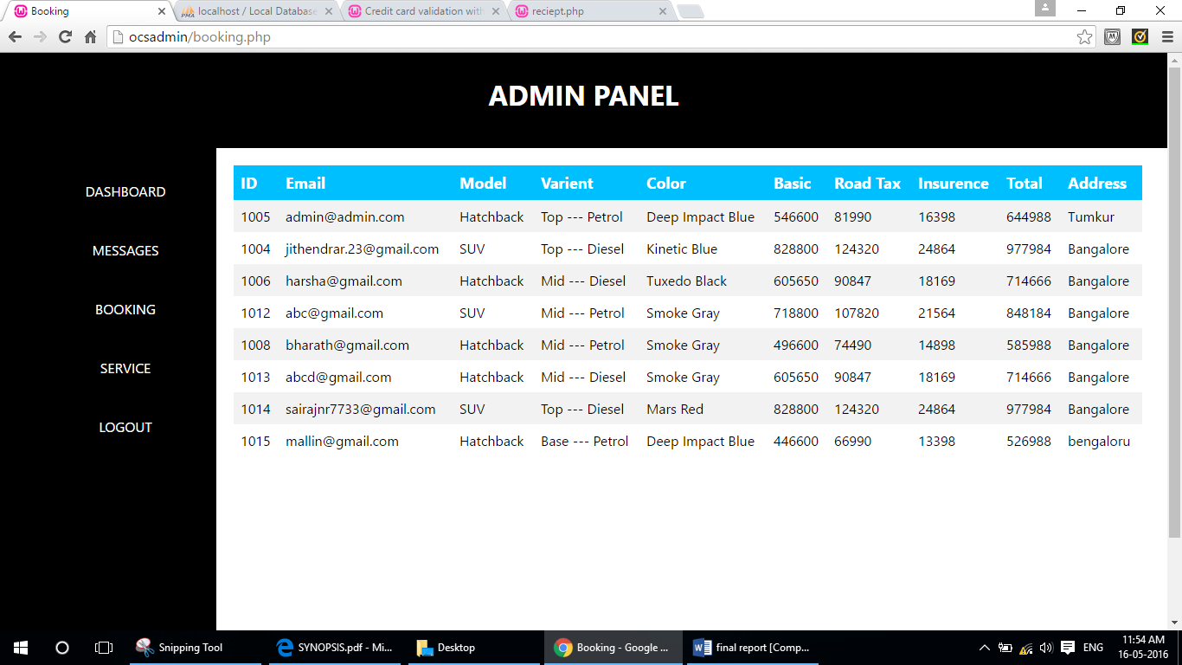

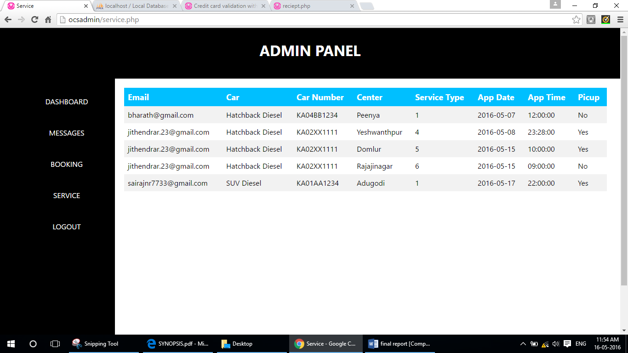

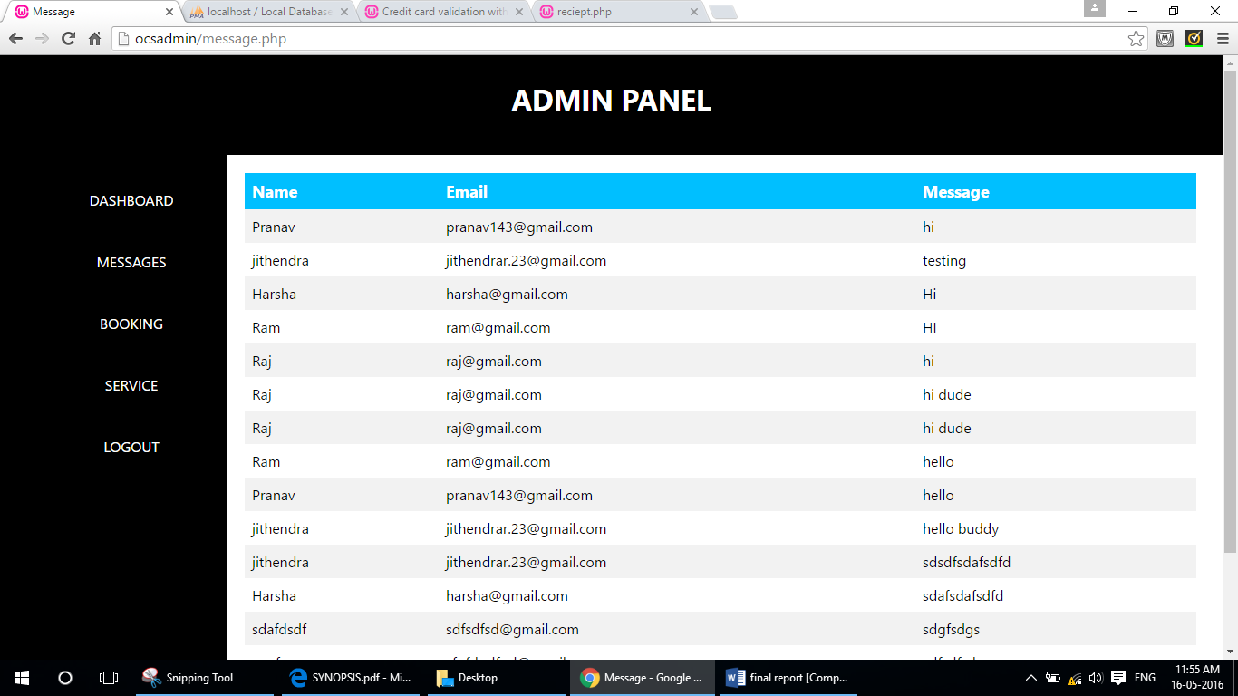

* 1. **Unit Testing**

Unit testing focuses verification effort on the smallest unit of Software design that is the module. Unit testing exercises specific paths in a module’s control structure to ensure complete coverage and maximum error detection. This test focuses on each module individually, ensuring that it functions properly as a unit. Hence, the naming is Unit Testing.

During this testing, each module is tested individually and the module interfaces are verified for the consistency with design specification. All important processing path are tested for the expected results. All error handling paths are also tested.

* 1. **Test cases**

|  |  |  |  |  |  |
| --- | --- | --- | --- | --- | --- |
| **Test ID** | **MODULE** | **GIVEN INPUT** | **EXPECTED OUTPUT** | **ACTUAL OUTPUT** | **RESULT** |
| 1. | Customer | Email ID and Password | If not the “Invalid entry” Message, If success the user will be entered according to role | If not the “Login Failed” Message, If success the user will be entered according to role | Tested OK |
| 2. | Admin | User name, password | Reflected to the database. | Reflected to the database. | Tested OK |

**CONCLUSION**

Automobiles have become such a part of our lives that we rarely stop to consider in how many ways they impact and shape the world in which we live. The emerging “automobile society” of twentieth-century America resulted in dependence not only on a single form of transportation, but on petroleum and petroleum products, the creation of automobile-scaled landscapes, the evolution of new urban and suburban forms, vast commercial development, engulfing and ambient pollution, and more. At the same time, it is too simple to heap all the blame on automobiles for the ills of society without admitting the cars and the opportunities they provide have been embraced by generations of Americans. Choices come with consequences. The choices of producers, consumers, policy makers, and those carrying the burden of policy making, have planted square in the middle of our culture an abiding and altering technology like few others.

It is safe to conclude that the Internet is a collection of new media that have a huge potential to be a popular channel for electronic commerce. This Online Solution resembles conventional in-home shopping in that the customer makes transactions without physically visiting a show room.

The Internet provides means to distribute marketing information in ways similar to conventional direct marketing, like catalogs and targeted direct mail. The Internet has other appealing properties too. It is cheap, and it helps personal communication between the seller and the buyer. It is useful for distributing digital products, and it can shorten the time between purchase decision and delivery. It also gives the customer certain extra benefits, like the ability to compare and discuss products.